AI Assited coding
Assignment 6.4: AI-Based Code Completion – Classes, Loops, and Conditionals
Name:Kanneboyina Meghana
Batch-44
HTNO:2303a52345
Task 1:Student Performance Evaluation System
Prompt: create methods to display student details and check performance using class average
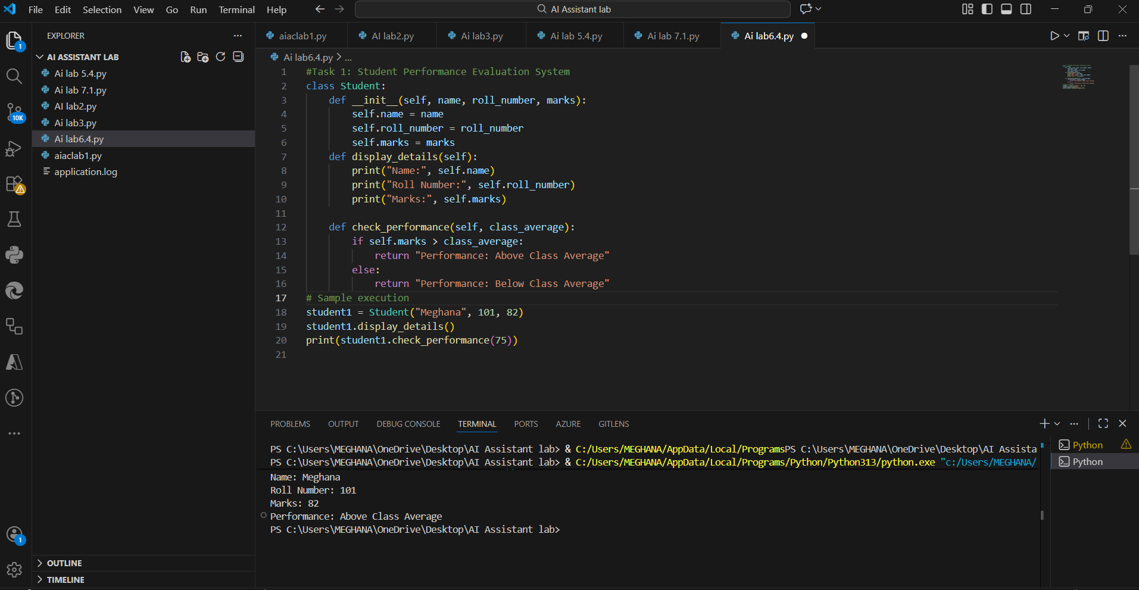
Explanation
1.self is used to access class attributes.
2.if-else checks performance against class average.
3.Methods are cleanly separated for clarity.
Task 2: Data Monitoring System
Prompt: Identify even numbers, calculate their square and print the result
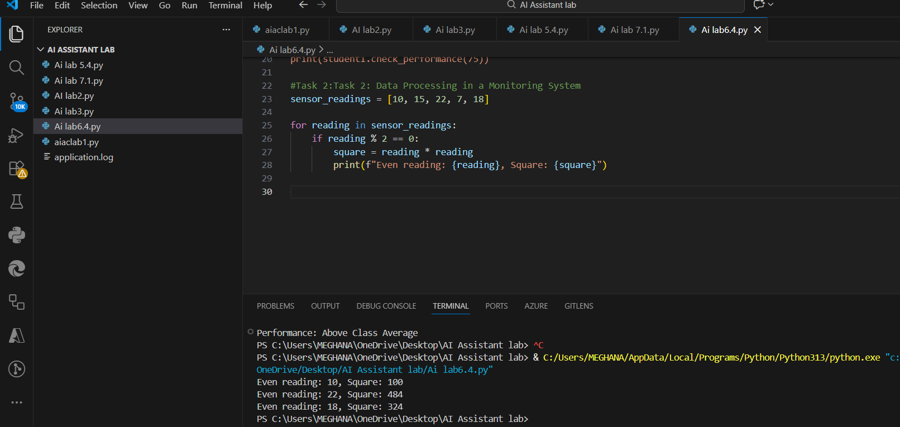
Explanation:
1.% operator checks even numbers.
2.Conditional statement filters valid readings.
3.Output is user-friendly and formatted.
Task 3: Banking Transaction Simulation
Prompt: implement deposit and withdrawal methods with balance validation
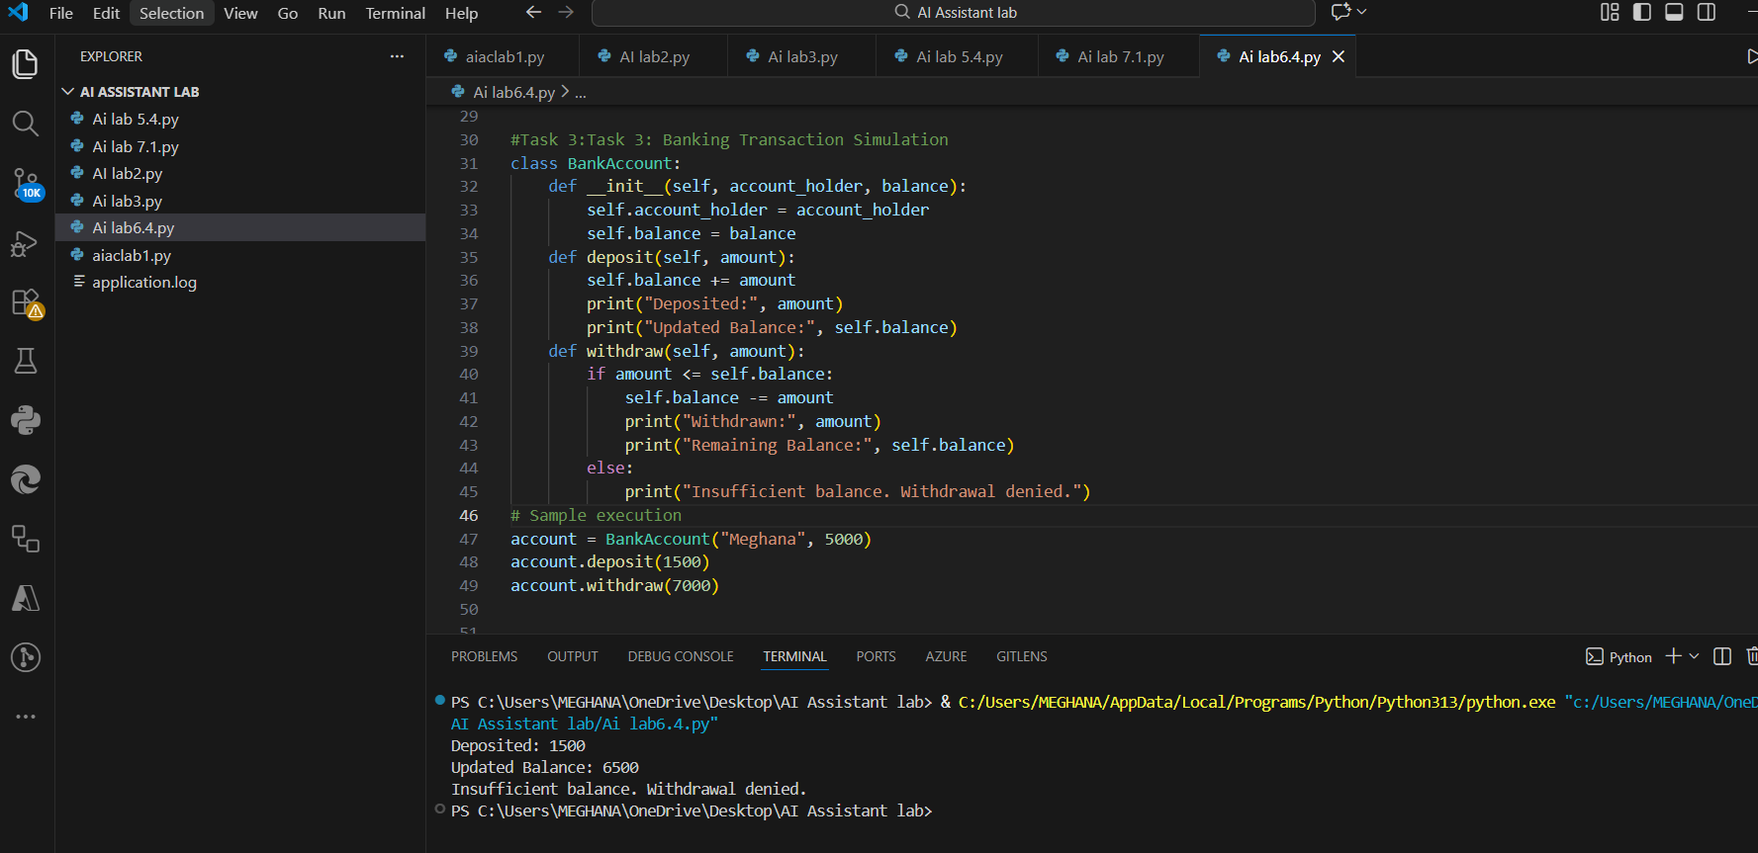
Explanation:
1.Balance safety ensured using if-else.
2.Friendly messages guide the user.
3.self.balance updates persist across methods.
Task 4: Student Scholarship Eligibility Check
Prompt: use a while loop to print names of students scoring above 75
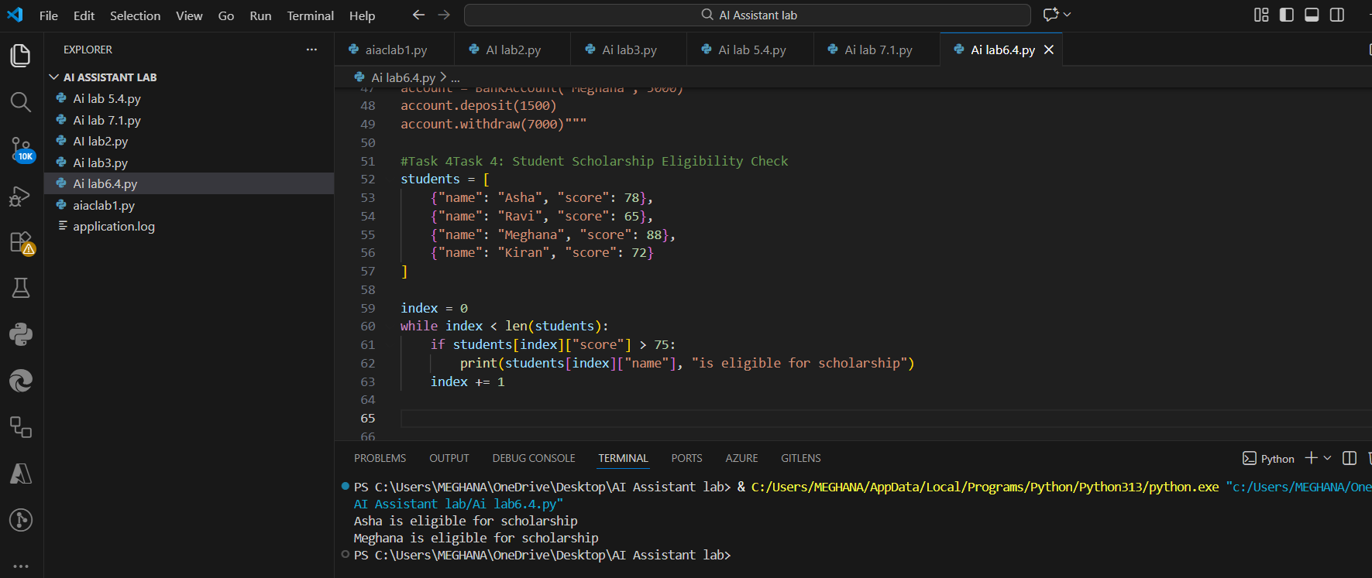
Explanation
1.while loop ensures manual index control.
2.Condition checks eligibility.
3.Clean output for selected students.

Task 5: Online Shopping Cart Module
Prompt: Implement cart operations including add, remove, total calculation and discount logic
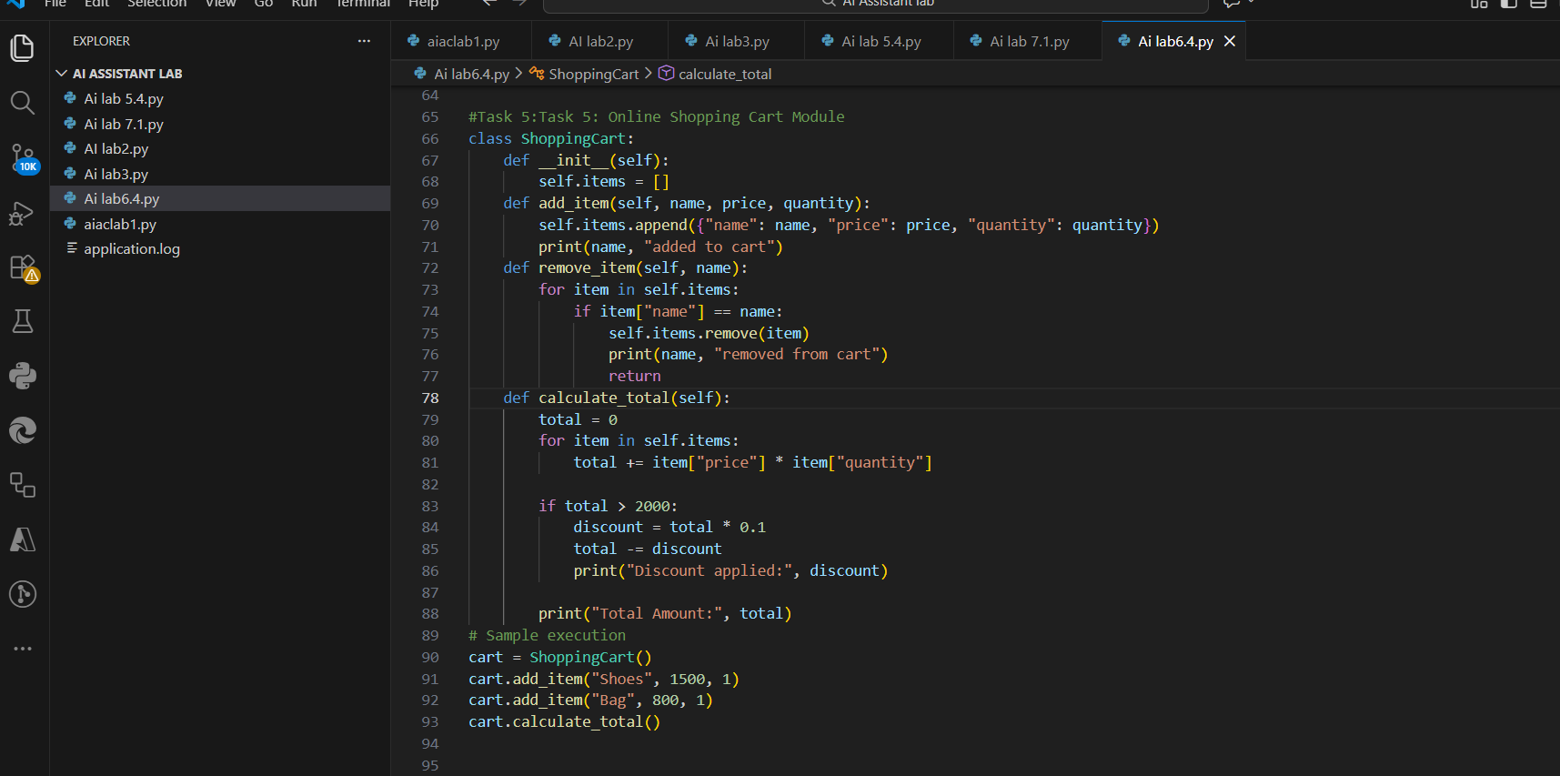
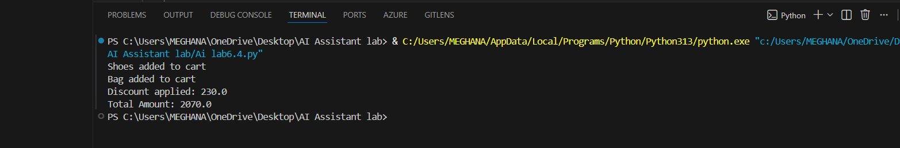
Explanation
1.List stores cart items.
2.Loop calculates total cost.
3.Conditional discount logic applied.
4.Supports add/remove operations.

